<https://www.youtube.com/watch?v=3xs5QuPTomU>

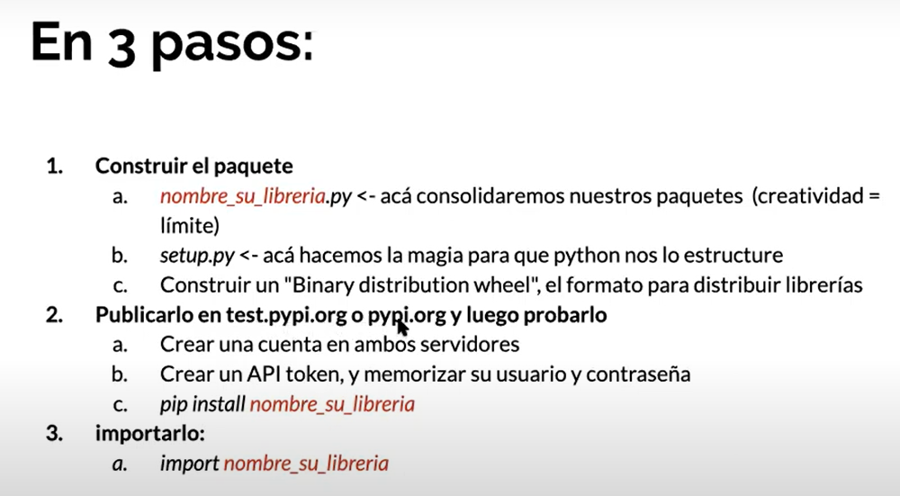

Sdsds

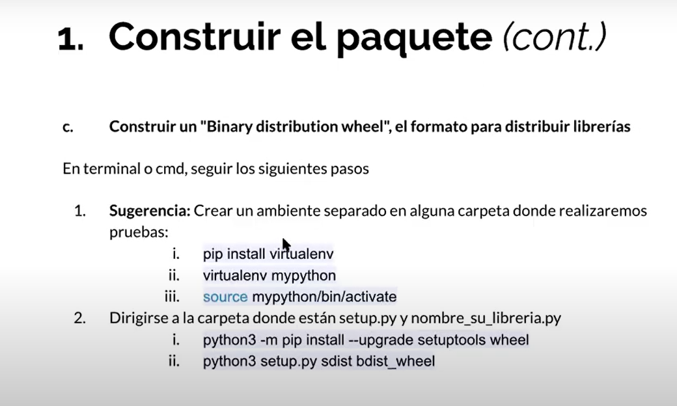

sdsds